Stanah Welcome Pack

Welcome to our school community! We are delighted to have you join our school family. At Stanah we believe every child deserves the best possible start in life, and we work together to create a safe, inclusive, and inspiring environment for learning.
Our Vision
“At Stanah Primary School, we nurture confident, kind, and resilient learners who are ready for the future — independent thinkers, emotionally aware, and motivated to grow, support others, work hard and embrace lifelong learning.”
We achieve this through a holistic, hands-on curriculum that fosters independence, emotional awareness, and a growth mindset. By modelling positive behaviours, setting clear expectations, and celebrating success, we empower children to self-regulate, take responsibility, and actively engage in their learning. Enrichment opportunities, scaffolding, and consistent praise support every child to thrive, reflect, and grow.
Our Values
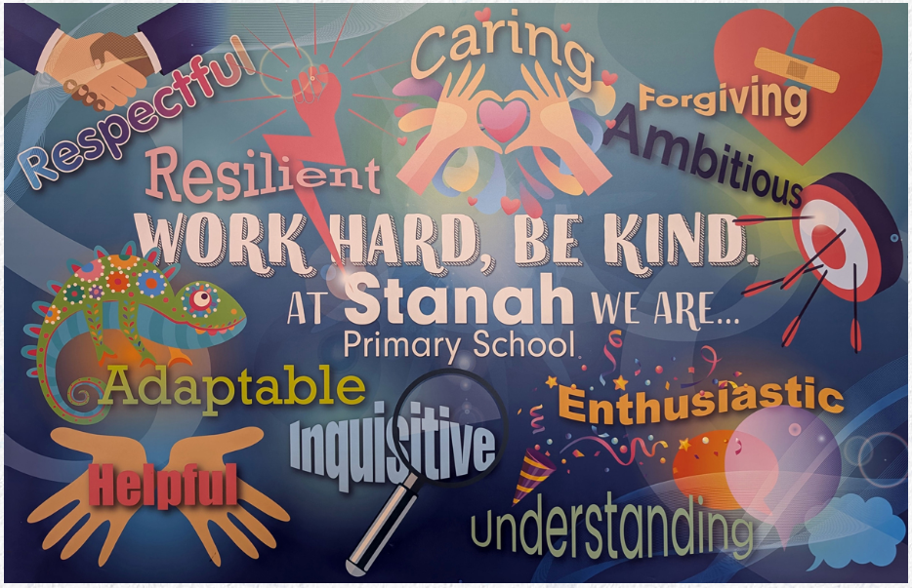
School Map
School Start and Finish Times
Doors Open at 8.40am until 8.55am. Children should all be in class and registered by 8.55am or they will receive a LATE mark.
EYFS and Key Stage 1 children finish school at 3.15pm.
Years 3 to 6 finish school at 3.20pm.
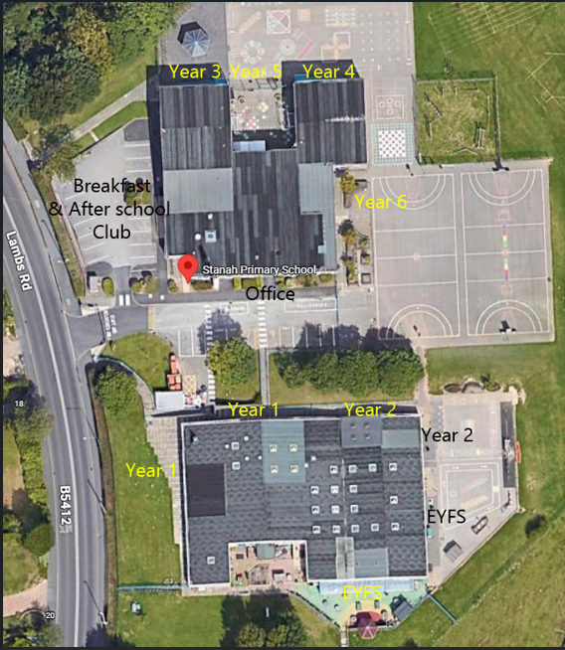
Please use this link to the following forms:
https://forms.gle/5egJKUpj7JKkwDXt5
Admission Form
Please provide all your child’s details for admission purposes. A paper one can be made available if you are unable to use the electronic one. Please hand in a copy of your child’s Birth Certificate. They can not start school until this has been seen.
Photo Consent Form
We often take photos of the children engaged in activities and attending events. These photos are used on class displays, on Class Dojo and sometimes the school website or social media.
Acceptable Use Form
Please read through our Acceptable Use rules with your child. This is to help us keep your child safe when using technology.
Local Area Visits
We try and provide lots of enrichment activities for our children. This can involve trips to the local shops, church visits and other local schools. Please provide consent for your child to take part in these. You will always be informed of any visits via Dojo.
Inhalers
If your child requires an inhaler in school, please provide details that will accompany your child’s inhaler in class.
Medical Needs and Allergies
If your child has any medical needs or known allergies, please speak to the office and we will organise a meeting for a Care Plan to be produced.
Administration of Medication
If your child has regular prescribed medication that must be administered during the school day, then a Care Plan will need to be devised for your child.
If your child is prescribed a course of medication and needs to have some administered during the school day, then you will need to hand the medicine in to the school office (DO NOT send with your child).
Non-prescribed medication can not be administered by school staff. Parents/carers will need to make arrangements to come into school to administer this eg. Calpol.
Class Dojo

We use a system called Class Dojo to communicate on a regular basis with parents. This can be used in a web browser or as an app. You will be issued a code to access your child’s Dojo. Please check this on a regular basis. Our weekly newsletter is posted on here every Friday after school. This is very informative and has lots of important dates.
School Lunches
For children in EYFS, Year 1 and Year 2, school lunches are paid for by the government. For Years 3 and above, school meals are charged at £2.70.
A menu is issued on our Newsletter each week so that the children can choose which days they have packed lunches and school dinners and they choose in class each morning.
Parentpay
 www.parentpay.com
We are a predominantly cashless school. You will be issued with a username and password to access a Parentpay account. You will receive notifications from Parentpay regarding school trips, breakfast club, after school club and lunches. Please ensure accounts are paid in a timely manner.
Breakfast Club and After School Club
We run a Breakfast Club from 7.30am and an After School Club until 5.45pm. If you require this service please ask for an application pack from the school office.
Fees are as follows:
Breakfast Club – full session | £4.50
Breakfast Club from 8.30am | £3.00
After School Club – full session | £7.70
After School Club – until 4pm | £4.00
Late Pick Up Fee (5.45pm – 6pm) | Additional £5.00
After 6pm a charge of £25 every 15 minutes will apply
Fees are paid via Parentpay. To contact Louise Haddow, the Manager of the club, please email clubs@stanah.lancs.sch.uk
Free School Meals Entitlement
Your child may be able to get free school meals if you get any of the following:
- Universal Credit with a household income of less than £7,400 a year (after tax and not including any benefits you get)
- Income-Based Jobseekers' Allowance
- Income-Related Employment and Support Allowance
- Child Tax Credit, not entitled to Working Tax Credit and household income less than £16,190
- Support under part VI of the Immigration and Asylum Act 1999
- Guarantee element of State Pension Credit
- Income Support
- Working Tax Credit 'run on' – the payment you receive for a further four weeks after you finish work
If you meet the above criteria, please apply for free school meals through this link:
https://www.lancashire.gov.uk/children-education-families/schools/free-school-meals/?page=3

School Milk
 www.coolmilk.com
If you would like your child to receive milk at school, please go onto the Cool Milk website and order it. For Under 5’s milk is free, for Over 5’s there is a cost of £18 per term.
Pupil Absence
If your child is unwell and unable to attend school, please call our absence line on 01253 825225 and Press 1. Leave a message with your child’s name and class and reason for not attending.
If we do not receive a call, we will phone you to make sure your child is ok. Home welfare checks will be carried out if we are unable to contact you for a reason for absence.
Stanah Superstar
Each week, a child from each class is chosen for demonstrating our School Values. This child is awarded the Stanah Superstar Certificate in a special assembly at 9am on Friday morning. If your child has been awarded Stanah Superstar, you will receive a text from school on a Wednesday. This is a secret from the children! We look forward to seeing you at a future assembly.
Onsite Parking
Parking is for Staff and authorised visitors ONLY from 7.45am until 4.30pm. This is to keep our children safe. The green gates are closed and locked between 9am and 3pm.
If you need to come on site, please park off site on the local roads – please be considerate of neighbours. Thank you.
If you have any reason to need to park on site please come and discuss this with office staff. If the reason is valid, you will be issued with a parking permit.


